Newington Road Surgery
Patient Survey Results
March 2019

Of 150 surveys handed out by receptionists a total of 76 were completed and returned by our patients.

Of those received:
21 Males,
46 Females
and 9 not specified (incomplete survey)

The age group distribution was as follows:

25 and under: 5 51 to 75: 28
26 to 50: 30 75 and over: 10
Not specified: 3 (incomplete survey)

The social economics distribution was as follows:

In part/full time education: 11
In part/full time employment 30
Unemployed 6
Retired 24
In receipt of Disability benefits 5

The survey results represent a reasonable variety of patients’ views due to the wide range of gender, age group ad the social class distribution.

The survey results to the questions were as follows.

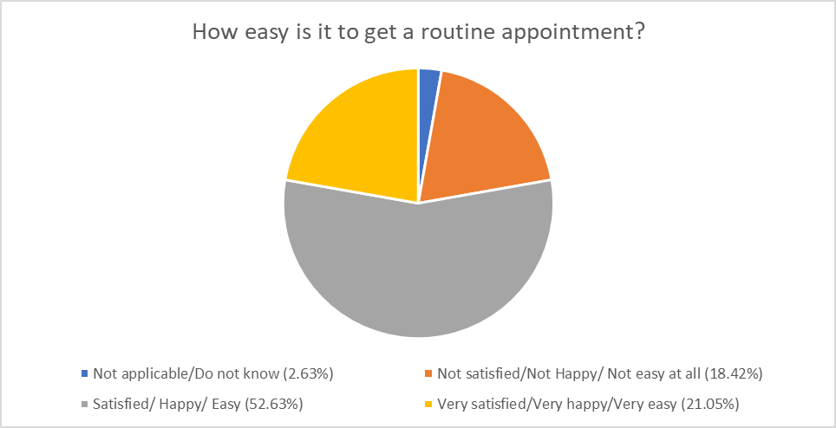
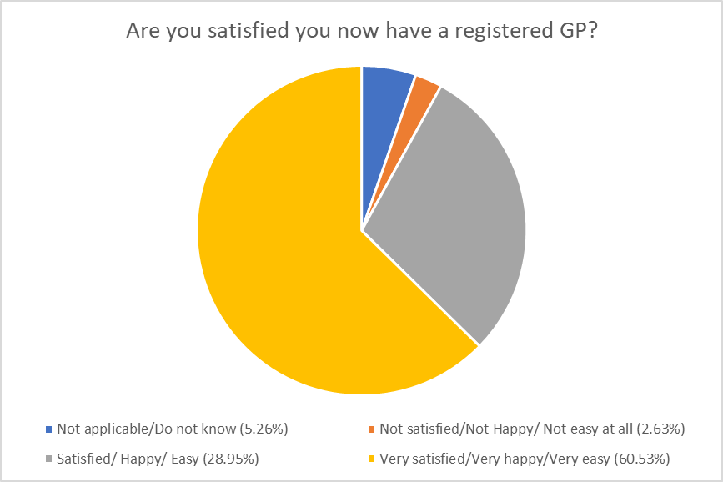

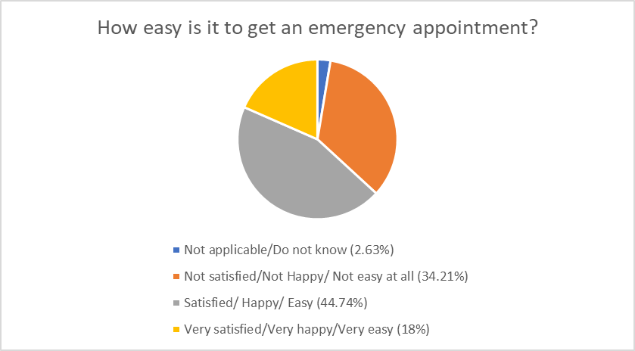
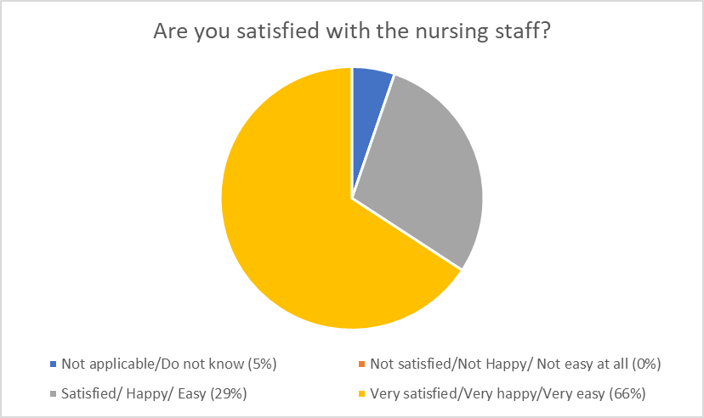

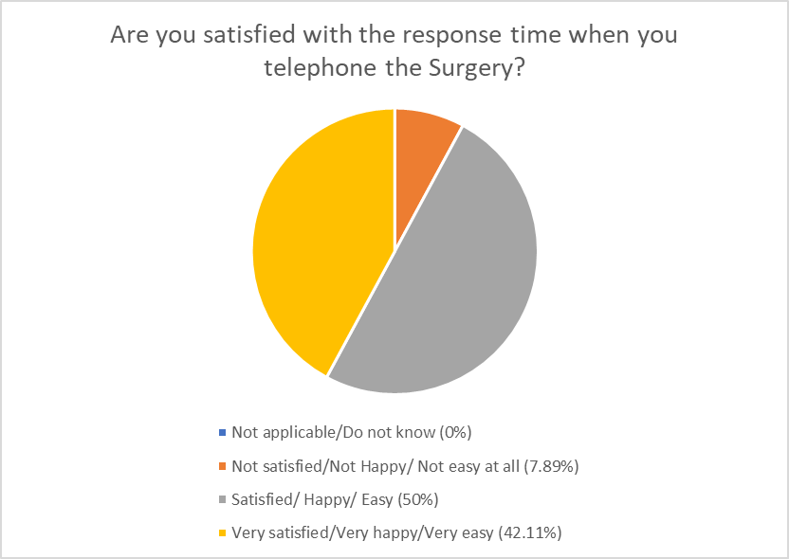

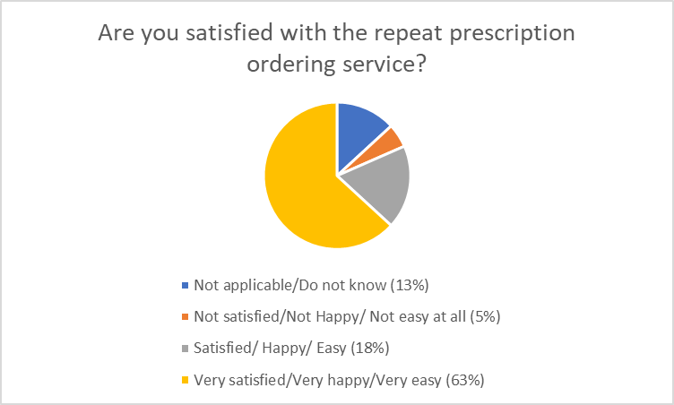

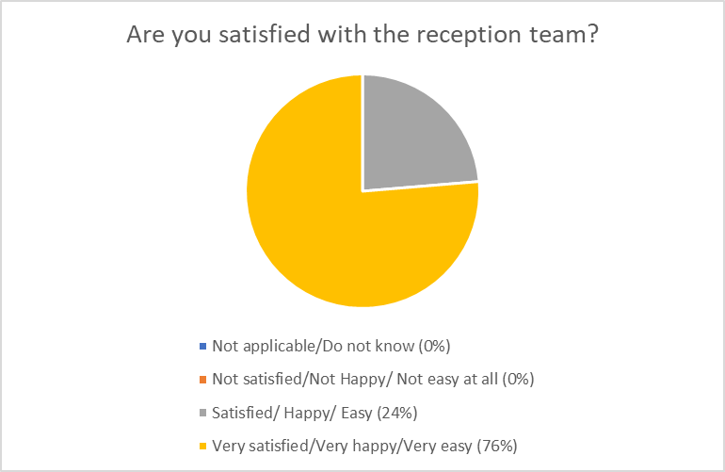
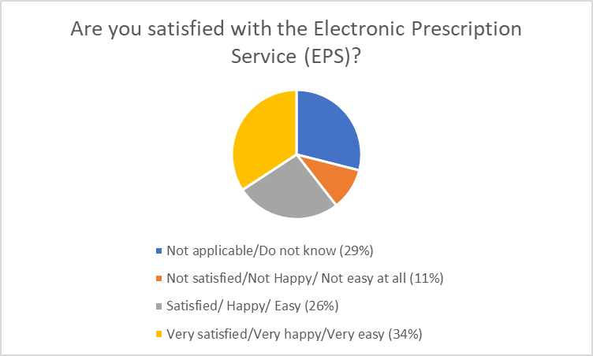

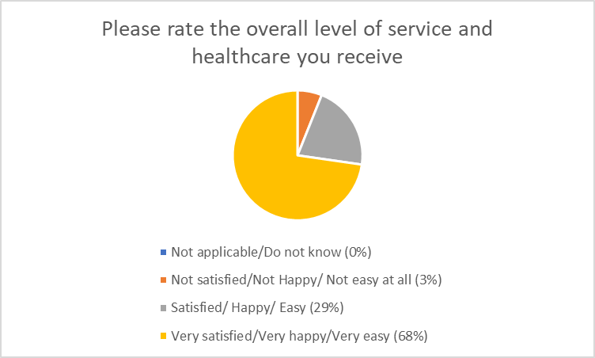
Is there any comments or suggestions you would like to make?

“Lovely staff”
“Reception staff are fabulous”
“Thank you for understanding me with my head injury”
“Very happy with all services received”
“Nurses very good”
“Very well run”
“Wait ages to get through on phone”
“Everyone here is always helpful and pleasant”
“Trying to ring when working to book an appointment for maybe in the afternoon is not easy as can’t take time off work”.
“Very rarely see Doctors”
“Lovely people”
“Never had need to complain”.
“Doctor really good”.

